# TemplateStep

**Objective:**

It is used to Load values into templates using Free marker template or Handlebars.

**Attributes:**

|  |  |
| --- | --- |
| **Attributes** | **Description** |
| value | Used to enter the expression which is in the form of handlebar or free marker template |
| value_type | To select type as free marker template or handlebar |
| output_variable | Used to store the response of the request |

**Sample config.json:**

{

"workflows":[

{  
 "id": "33_uploadlog4j2",  
 "name": "33_uploadlog4j2",  
 "trigger": "rest",  
 "expression": "/app/upload/template/log4j2",  
 "method": "GET",  
 "steps": [  
 {  
 "id": "1",  
 "type": "s3-file-download",  
 "fileName": "log4j2.xml",  
 "output_variable": "_logtemplate",  
 "bucketPath": "appup-bucket/appup/deployment-templates",  
 "value_type": "hb",  
 "plugin_name": "appup_bucket",  
 "next": {  
 "success": "getdownloadfile",  
 "failure": "hangup"  
 }  
 },  
 {  
 "id": "getdownloadfile",  
 "type": "template",  
 "value": "{{{bytes2string _logtemplate}}}",  
 "value_type": "hb",  
 "output_variable": "output",  
 "next": {  
 "success": "success",  
 "failure": "hangup"  
 }  
 },

{

"variable_name": "output",

"http_response_code": "200",

"response_content_type": "text/html",

"value_type": "hb",

"type": "send",

"id": "success",

"next": {

"success": "hangup",

"failure": "hangup"

}

}

]  
 },

],

"filters":[],

"server":{},

"plugins":[]

}

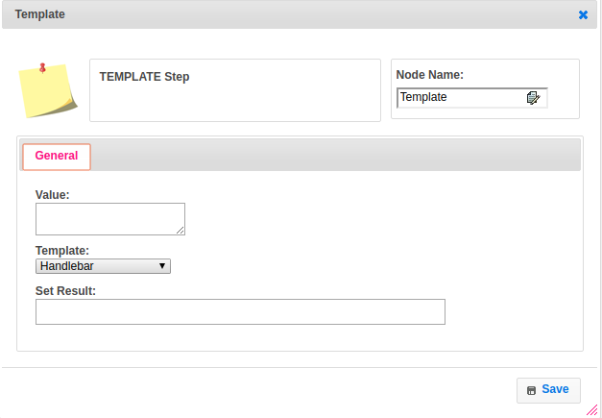

**Executor Description:**

It is used to load the values into templates using free marker template or handlebars by using Template Util class and put this template into output variable then returns success.